CPRE 1850 – The DS4 Equalizer

LAB 6
SECTION CN

SUBMITTED BY:

MAXWELL MILLER

10/31/2025
Problem

Analysis

Design

Testing

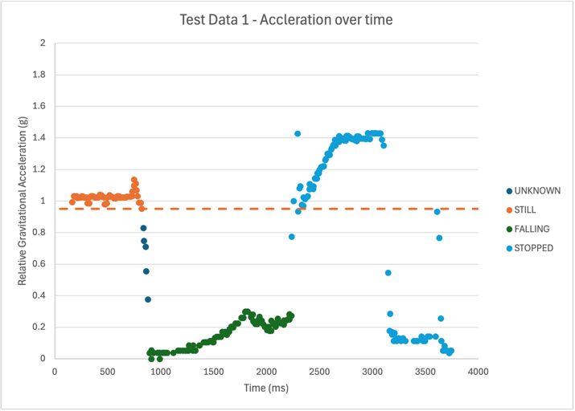
Comments

Code implementation
// 185 lab6.c
#include <stdio.h>
#include <stdlib.h>
#include <math.h>
#define PI 3.141592653589

// Functional Prototypes
int read_line(int* time, double* g_x, double* g_y, double* g_z, int* Button_T, int* Button_C, int* Button_X, int* Button_S);
double roll(double x_mag);
double pitch(double y_mag);
int scaleRadsForScreen(double rad);
void print_chars(int num, char use);
void graph_line(int number);

// Enum for mode selection with the controller button
enum Mode {
ROLL_MODE,
PITCH_MODE
};

int main()
{
double x, y, z; // magnitude values of x, y, and z
int b_Triangle, b_X, b_Square, b_Circle; // variables to hold the button statuses
double roll_rad, pitch_rad; // value of the roll measured in radians
int scaled_value; // value of the roll adjusted to fit screen display

int time;
enum Mode mode = ROLL_MODE; // Default to roll mode
int val;

do
{
// Get line of input
read_line(&time, &x, &y, &z, &b_Triangle, &b_Circle, &b_X, &b_Square);

// calculate roll and pitch. Use the buttons to set the condition for roll and pitch
roll_rad = roll(x);
pitch_rad = pitch(y);
Continued on the next page.

// switch between roll and pitch(up vs. down button)
if (b_Triangle) {
if (mode == ROLL_MODE) {
mode = PITCH_MODE;
}
else {
mode = ROLL_MODE;
}
}

// Scale your output value
if (mode == ROLL_MODE) {
val = scaleRadsForScreen(roll_rad);
}
else if (mode == PITCH_MODE) { // Written this way for clarity
val = scaleRadsForScreen(pitch_rad);
}

// Output your graph line
graph_line(val);

fflush(stdout);
} while (!b_Square); // Stops when the square button is pressed

return 0;
}

int read_line(int* time, double* g_x, double* g_y, double* g_z, int* Button_T, int* Button_C, int* Button_X, int* Button_S) {
scanf("%d, %lf, %lf, %lf, %d, %d, %d, %d", time, g_x, g_y, g_z, Button_T, Button_C, Button_X, Button_S);

return (*Button_S);
}

double roll(double x_mag) {
if (x_mag > 1.0) { x_mag = 1.0; }
if (x_mag < -1.0) { x_mag = -1.0; }

// Negative to make the roll make visual sense on the screen
// ie Left is left, right is right
return -asin(x_mag);
}
Continued on the next page.

double pitch(double y_mag) {
if (y_mag > 1.0) { y_mag = 1.0; }
if (y_mag < -1.0) { y_mag = -1.0; }

return asin(y_mag);
}

int scaleRadsForScreen(double rad) {
// -PI/2 to PI/2 -> -1 to 1 -> -39 to 39
return (rad * (2 / PI)) * 39;
}

void print_chars(int num, char use) {
for (int i = 0; i < num; i++) {
printf("%c", use);
}
}

void graph_line(int number) {
int side = 39 - abs(number);

if (number < 0) {
print_chars(side, ' ');
print_chars(abs(number), '|');
}

else if (number == 0) {
print_chars(39, ' ');
print_chars(1, '0');
}

else {
print_chars(39, ' ');
print_chars(number, 'r');
}

print_chars(1, '\n');
}

